**Constant current and Constant voltage source for charging a battery**

**Introduction**

The typical batteries such as Li-Po batteries, Lead Acid batteries etc. use the constant current- constant voltage (CC/CV) charge method. A regulated constant current raises the terminal voltage of the plugged battery until the desired upper charge voltage limit is reached, at which point the current drops due to saturation of the battery. Charging stages of the aforementioned batteries can be divided into three stages, which are

1. Constant-current charge
2. Topping charge
3. Float charge

The constant-current charge applies a large amount of the charge and takes up roughly half of the required charge time, the topping charge continues at a lower charge current and provides saturation, and the float charge compensates the loss caused by self-discharge. During the constant-current charge, the battery charges to about 70 percent and the remaining 30 percent is filled with the slower topping charge that lasts for much long time. The topping charge is essential for the well-being of the battery and can be compared to a little rest after a heavy meal. If continually deprived, the battery will eventually lose the ability to accept a full charge. The float charge in the third stage maintains the battery at full charge. The three stages are shown below in the figure1.

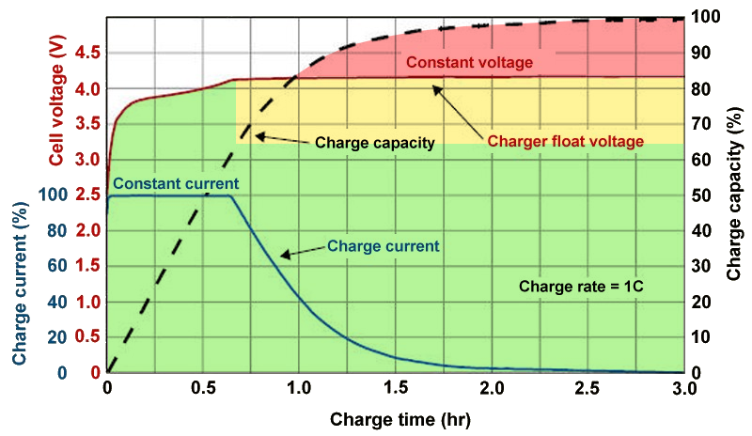

Figure 1- Charging stages of a Li-Po battery

Source: https://cdn57.androidauthority.net/wp-content/uploads/2018/07/Battery-Charge-Voltage-vs-Time.png

**Project Outline**

**Passive Low Pass Filter**

**PWM Generator**

**Ramp Signal Generator**

**Operation Amplifier as a Comparator**

**(Switching Converter)**

**Battery**

**Feedback**

**Switch**

Figure 2 – Project Outline

**Problems that we faced and Solutions**

1. ***Issue of high-power dissipation in the circuit***

When we were analyzing the circuits that were already available for the constant current source and the constant voltage source in the internet and in the books, our main observation was the high-power dissipation in the analyzed circuits. In order to overcome the high-power in the circuits those circuits used cooling fans, heatsinks and power transistors to dissipate the excessive energy. An Example circuit is given in the figure 3.

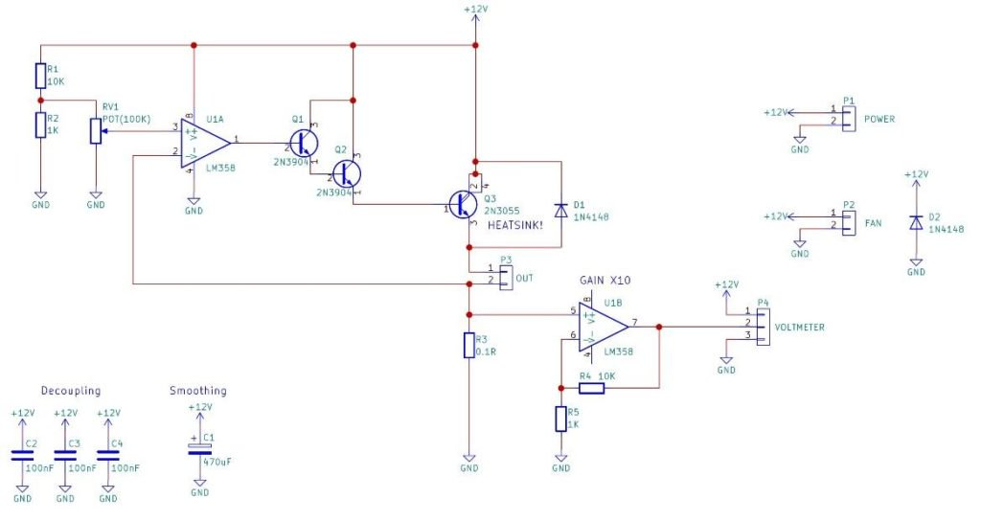

Figure 3- High-power dissipation in the circuit

Source: https://maker.pro/storage/thvZgtC/thvZgtCUTFhjFiXmctDlRBLIjAGv8RODnvEk2sD4.jpeg

To overcome these issues, we decided to use a PWM signal to give the constant current and the constant voltage. In a typical PWM signal the effective time of the quantity being active is considerably small and hence the effective rms or average of the considered quantity is small. Eventually the power dissipated from the circuit is small when we consider a PWM signal of voltage or current.

1. ***Present circuit consists of too many components***

Even though the modified circuit has less power dissipation, it consists of too many components. Therefore, our goal is to optimize the ramp generator circuit.

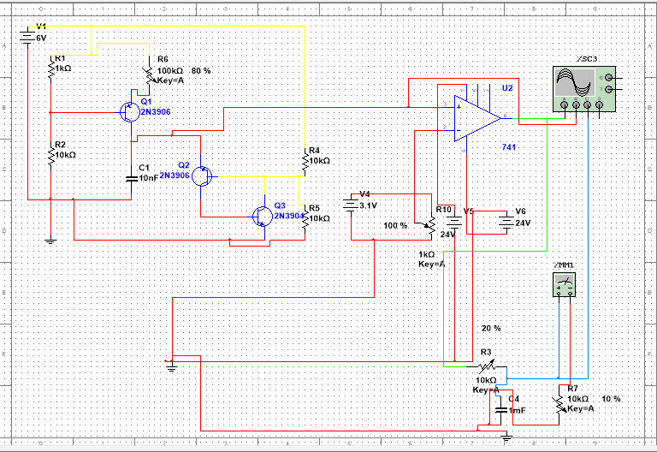**Simulation Results**

Figure 4 – Direct Current Controller Circuit

The generated ramp signal is fed to one of the input terminals of the OPAMP and feedback from the battery to be charged is sent as the other input signal to the OPAMP. In this circuit the OPAMP is used as a comparator and this feedback signal will be the threshold value to obtain the PWM signal. This signal is sent to the low pass filter to obtain the desired DC value. This voltage will be used to charge the battery and it will be controlled by the feedback voltage.

Following are the simulated results according to the different threshold values (currently the threshold values are given by us by varying the potentiometer):

1. Ramp Signal Generator

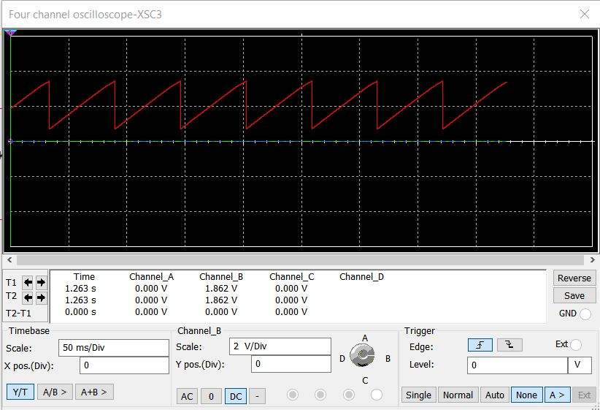

1. Pulse Width Modulation(PWM)

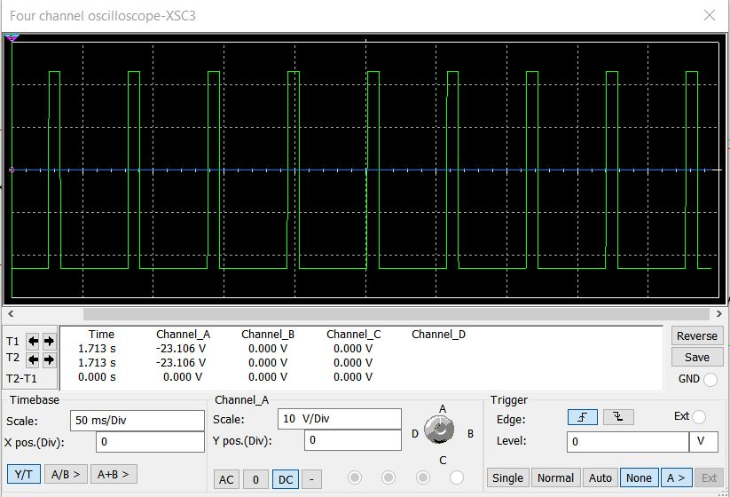

1. Corresponding Direct Current

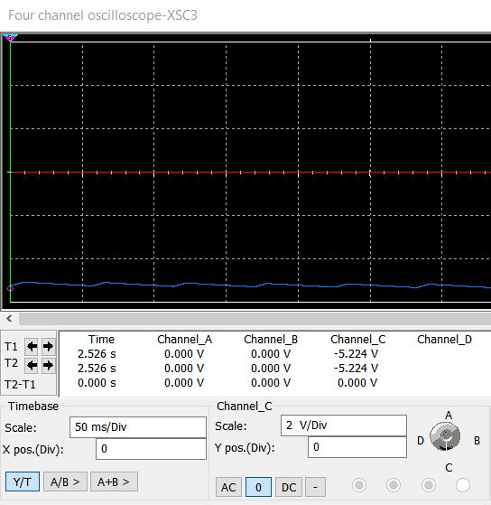

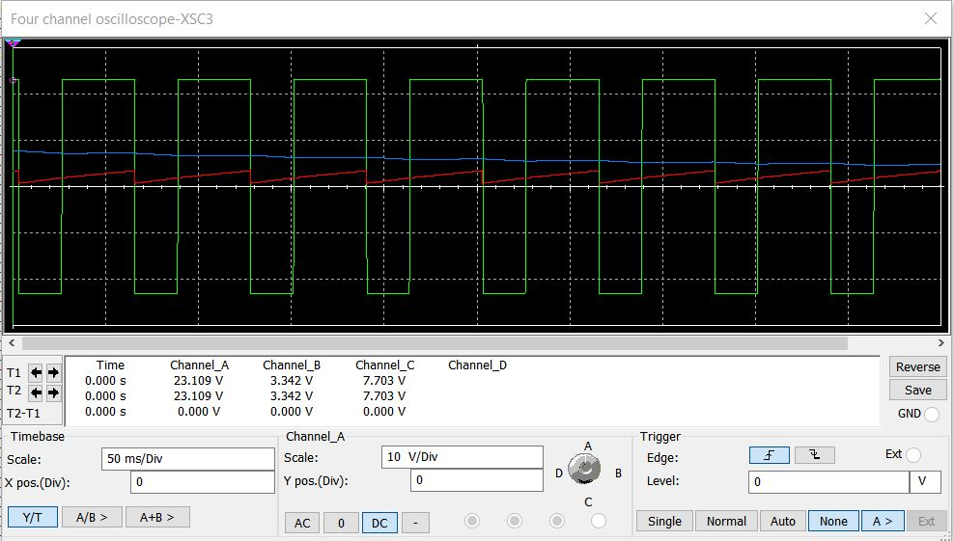

**Simulation results with all operations**

